Testcase 1/2:

* OFFLINE straight few days + Timezone
* PROJECTPRESENCEENDTIME = 23:59:59.000 and PROJECTPRESENCEENDTIME starts at 00:00:00.000 on next day if SYSTEMPRESENCE goes overnight in D_PI_PRIMARY_PRESENCE_VW view

Table: **D_PI_PRIMARY_PRESENCE_VW**

Query:

select USERID, DURATION, PRESENCESTARTDATE, ORGANIZATIONPRESENCE, PRESENCESTARTTIME, PRESENCEENDTIME, SYSTEMPRESENCE

from "PUREINSIGHTS_DEV"."PUBLIC"."D_PI_PRIMARY_PRESENCE_VW"

where PROJECTID = '9999'

and USERID = '68063bad-14a3-4d39-8cf7-5ad6af21a62f'

and PRESENCESTARTDATE = '2020-04-27';

Data:

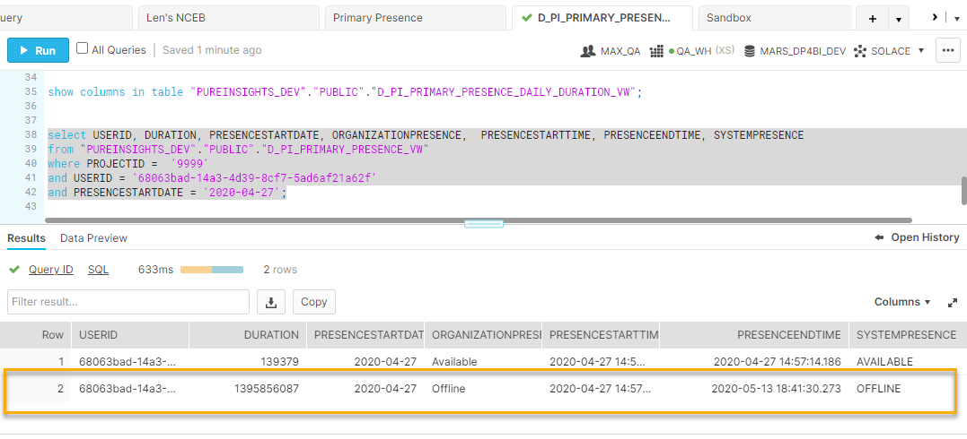

Table: **D_PI_PRIMARY_PRESENCE_DAILY_DURATION_VW**

Query:

select PROJECTID, USERID, PROJECTPRESENCESTARTDATE, PROJECTPRESENCESTARTTIME, PROJECTPRESENCEENDTIME, SYSTEMPRESENCE, DAILYDURATION, TOTALDURATION

from "PUREINSIGHTS_DEV"."PUBLIC"."D_PI_PRIMARY_PRESENCE_DAILY_DURATION_VW"

where projectid = '9999'

and USERID = '68063bad-14a3-4d39-8cf7-5ad6af21a62f'

and SYSTEMPRESENCE = 'OFFLINE'

and PROJECTPRESENCESTARTDATE >= '2020-04-27';

Data:

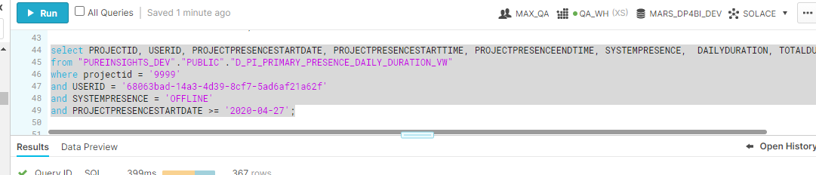

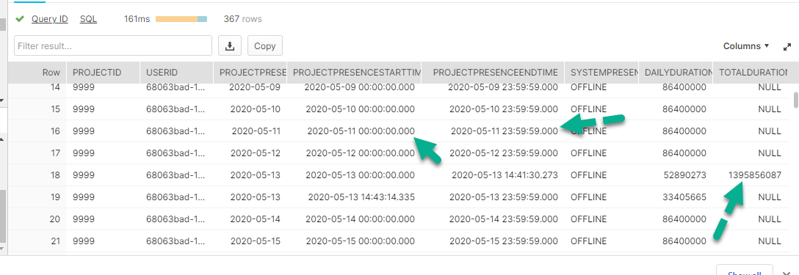

Testcase 3: **D_PI_PRIMARY_PRESENCE_VW go overnight (**two records in **D_PI_PRIMARY_PRESENCE_DAILY_DURATION_VW + timezone)**

**Note: Last IDLE activity goes through midnight from 2021-01-19 to 2021-01-20.**

Table: **D_PI_PRIMARY_PRESENCE_VW**

Query:

select USERID, DURATION, PRESENCESTARTDATE, ORGANIZATIONPRESENCE, PRESENCESTARTTIME, PRESENCEENDTIME, SYSTEMPRESENCE

from "PUREINSIGHTS_DEV"."PUBLIC"."D_PI_PRIMARY_PRESENCE_VW"

where PROJECTID = '9999'

and USERID = '71293a1e-9422-44af-878e-54d5198dacbe'

and PRESENCESTARTDATE >= '2020-11-18';

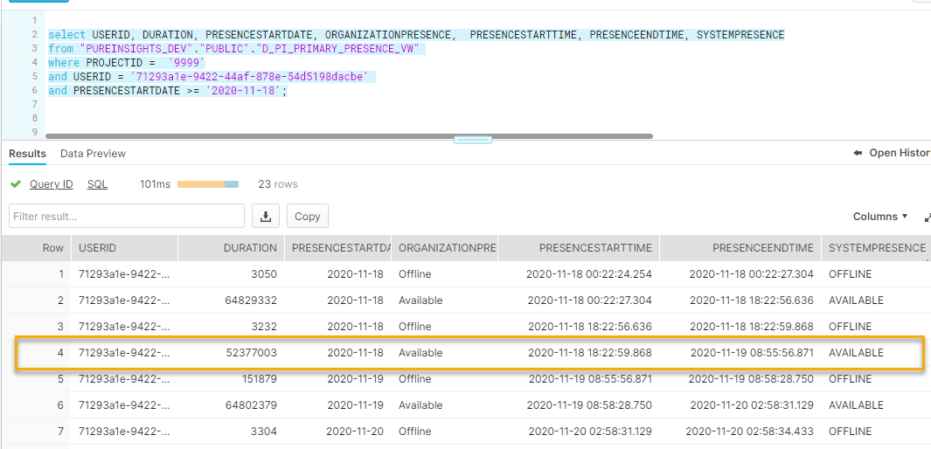

Table: **D_PI_PRIMARY_PRESENCE_DAILY_DURATION_VW**

Query:

select PROJECTID, USERID, DATE, DAILYPRESENCESTARTTIME, DAILYPRESENCESTARTTIME, SYSTEMPRESENCE, DAILYDURATION, TOTALDURATION

from "PUREINSIGHTS_DEV"."PUBLIC"."D_PI_PRIMARY_PRESENCE_DAILY_DURATION_VW"

where projectid = '9999'

and USERID = '71293a1e-9422-44af-878e-54d5198dacbe'

and DATE >= '2020-11-18';

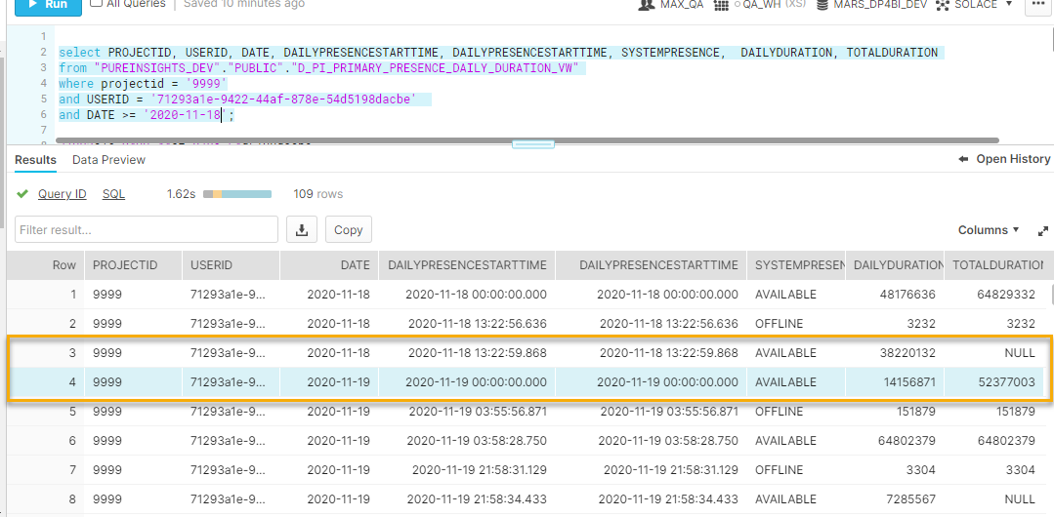

Testcase 4: **PRESENCESTARTTIME shift to another day because of timezone.**

**Note: IDLE**

Table: **D_PI_PRIMARY_PRESENCE_VW**

Query:

select USERID, DURATION, PRESENCESTARTDATE, ORGANIZATIONPRESENCE, PRESENCESTARTTIME, PRESENCEENDTIME, SYSTEMPRESENCE

from "PUREINSIGHTS_DEV"."PUBLIC"."D_PI_PRIMARY_PRESENCE_VW"

where PROJECTID = '9999'

and USERID = '71533939-7330-4021-9e5d-557ce4e588dd'

and PRESENCESTARTDATE = '2021-01-09';

Data:

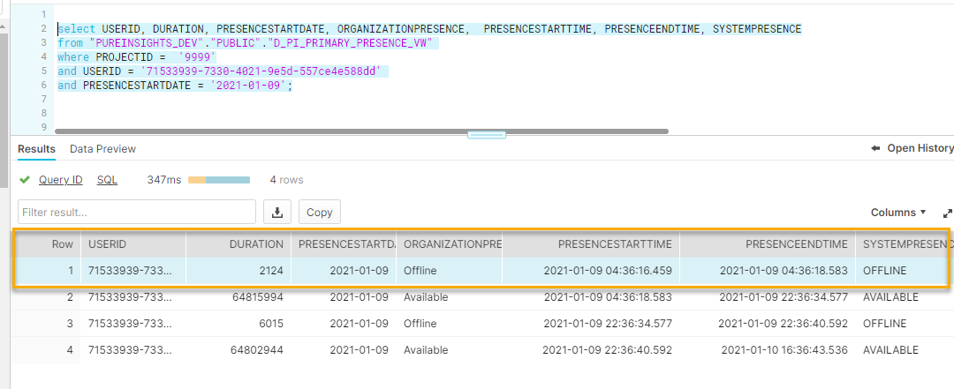

Query:

select PROJECTID, USERID, DATE, DAILYPRESENCESTARTTIME, DAILYPRESENCESTARTTIME, SYSTEMPRESENCE, DAILYDURATION, TOTALDURATION

from "PUREINSIGHTS_DEV"."PUBLIC"."D_PI_PRIMARY_PRESENCE_DAILY_DURATION_VW"

where projectid = '9999'

and USERID = '71533939-7330-4021-9e5d-557ce4e588dd'

and DATE >= '2021-01-08';

Data:

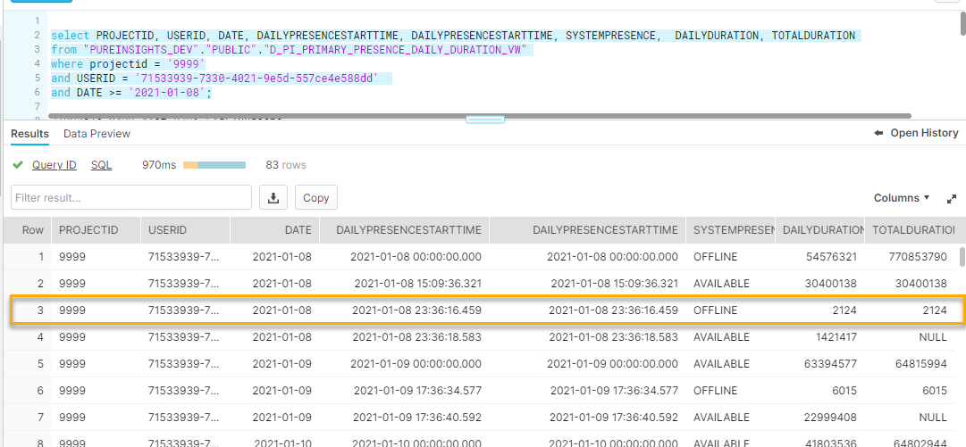

**Testcase 5:** The same **SYSTEMPRESENCE** but different **ORGANIZATIONPRESENCE**

**Note: IDLE**

Table: **D_PI_PRIMARY_PRESENCE_VW**

Query:

select PROJECTID, USERID, DURATION, ORGANIZATIONPRESENCE, PRESENCESTARTTIME, PRESENCEENDTIME, SYSTEMPRESENCE, PRESENCESTARTDATE,PRESENCEENDDATE

from "PUREINSIGHTS_DEV"."PUBLIC"."D_PI_PRIMARY_PRESENCE_VW"

where PROJECTID <> '741'

and USERID = 'ee59125c-7c4c-453b-a43f-7bcbb36ef790'

and PRESENCESTARTDATE >= '2021-02-03'

ORDER BY PRESENCESTARTTIME ASC;

Data:

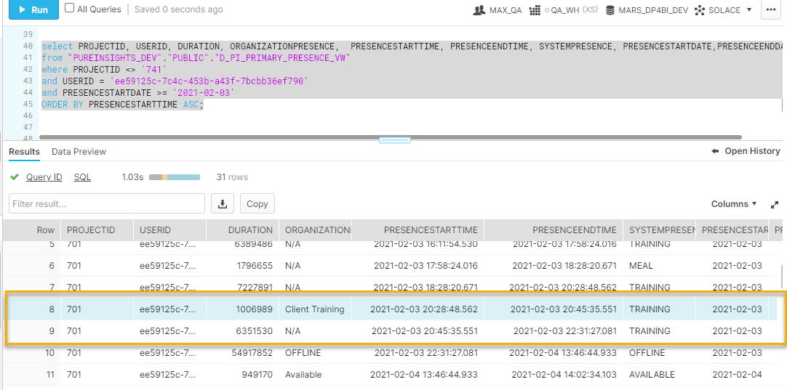

Table: **D_PI_PRIMARY_PRESENCE_DAILY_DURATION_VW**

Query:

select PROJECTID, USERID, DATE, DAILYPRESENCESTARTTIME, DAILYPRESENCEENDTIME, SYSTEMPRESENCE, ORGANIZATIONPRESENCE, DAILYDURATION, TOTALDURATION

from "PUREINSIGHTS_DEV"."PUBLIC"."D_PI_PRIMARY_PRESENCE_DAILY_DURATION_VW"

where USERID = 'ee59125c-7c4c-453b-a43f-7bcbb36ef790'

and SYSTEMPRESENCE = 'TRAINING';

Data:

